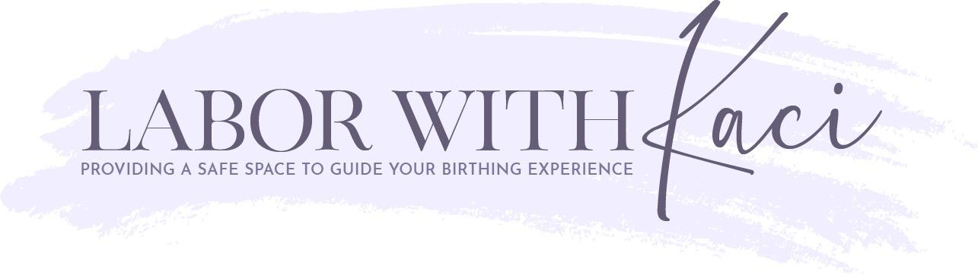 Menu of Services

Virtual Amour’ Package $950  (via Facetime, Zoom, or Skype)  - 3 Prenatal Sessions Including:  - Prenatal Coaching/Education  - Planning for Birth, Written Wishes, etc.  - Prenatal Support by Email & Phone  - On-Call Labor Support Including:  - On-Call 2 Weeks Starting Prior to Due Date  - Non-Medical Pain/Comfort Measures  - Informational & Emotional Advocacy  - All Classes Including (in-person or online):  - Childbirth Education Class Series  - Newborn Care Class  - Breastfeeding 101 Class  - In-home labor and In-Home Lactation Support Including:  - Labor support at home before heading to hospital  - Phone call availability during labor to help assist with birth options, answer questions and help deciding when it is time to go to your hospital or birth center (video chat is also available if you prefer)  - 1 In-Home Postnatal Session:  - 1 Post-Birth Meeting (can be combined with Lactation)  - Resourcing and Referrals  Virtual Adore’ Package $425  (via Facetime, Zoom, or Skype)  - 1virtual Prenatal Sessions Including:  - Prenatal Coaching/Education  - Planning for Birth, Written Wishes, etc.  - Assist in "Greening" Home for Baby  - Prenatal Support by Email & Phone  - Access to Free Lending Library  - On-Call Labor Support Including:  - On-Call 2 Weeks Pre/Post Due Date  - Phone call availability during labor to help assist with birth options, answer questions and help deciding when it is time to go to your hospital or birth center  - Non-Medical Pain/Comfort Measures  - Informational & Emotional Advocacy  - 1 virtual Postnatal Session:  - 1 Post-Birth Processing/Counseling Meeting  - Resourcing and Referrals  Lactation Bonding Support - $100/visit  - On-Call 24/7 Breastfeeding Support  - In-Home and First Arrival Consultations  - Milestone and Weaning Support  - Special Needs Infant Feeding Care  - Breastfeeding 101 Class – Private - $150  Spend 2 hours learning the basics with practical, real-life wisdom that will assist you with your bab(ies) first nutrition and nurturing. | Postpartum Swaddle Packages and Fees  - In-Home Care after Baby’s Arrival Including:  - Customized, In-Home Baby Education  - Newborn Sleep Assistance  - Nutritional Assessment by our Licensed Dietician  - Assist in "Greening" Home for Baby  - Informational & Emotional Advocacy  - In-Home Breastfeeding Support  - Postpartum Birth Experience Counseling  - Light Housekeeping; Laundry, Dishes  - Nutritious Meal Planning and Prep  - Postpartum Depression Prevention  - Depression / Mood Disorder Recovery Care  - Cesarean Recovery Support  - Multiples Care and Education  - Sibling Assistance  - Use of Any/All Lending Library Items & Resources  …and so much more, as needed!  Day Time Hourly Postpartum Rate $35/hr  (Day shifts:4 hour minimum)  Overnight Shift $300/Night  (8 hour shift)  Sleep Consultant Services $199 initial  - Infant Sleep Solutions: No-Cry Sleep Training  - Skype/FaceTime initial consult  - 1 In-home session ($175 for added visits)  - Email, text and phone support for 30 days  - Written personal checklist – plan for better sleep  - Free admission to Infant Sleep Solutions class  A La Carte  Virtual Birth Doula Services Menu:  - Services Include: guidance with birth plan, discussion of labor and birth options, creating your birth environment and discussing induction options just to name a few! All information is evidence based.  - One 30-minute call: $30  - One 60-minute call: $65  - Three 60-minute call Package: $200  - Six 55 minute ca;; Package: $400  Virtual Postpartum Doula Services Menu:  - Services include: breastfeeding support, comfort measures, information on paced feedings, baby-wearing support and so much more!  - One 30-minute call: $30  - One 60-minute call: $65  - Three 60-minute call Package: $200

